### **Configure Selenium in Eclipse**

Here are the steps to configure Selenium Webdriver with Eclipse:

**Step 1: Launch Eclipse**

To launch Eclipse double click on the **eclipse.exe** file in the download location.

**Step 2: Create Workspace in Eclipse**

This workspace named “**C:\BrowserStack**” is like any other folder, which will store all the test scripts. Launch the BrowserStack workspace.

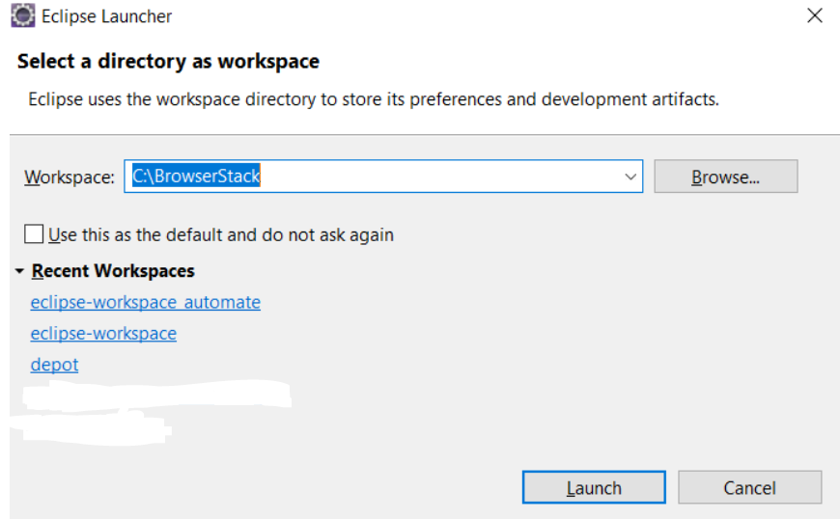

***Creating Workspace in Eclipse***

**Step 3: Create New Java Project in the BrowserStack Workspace**

Create a new Java Project by clicking on **File > New > Java Project** and name it.

***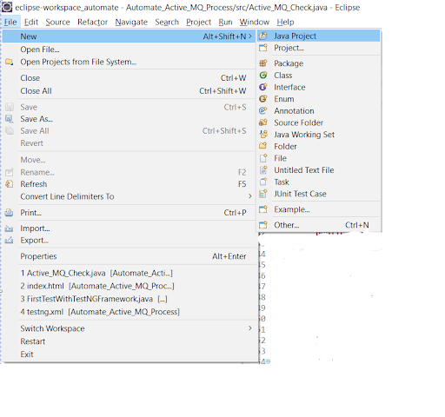  
Creating a new Java Project***

**Step 4: Create Package and Class under the Java Project**

By clicking on the **src folder** (which is the source folder), create a new package and name it (BrowserStack). Then right-click on the package name and create a class.

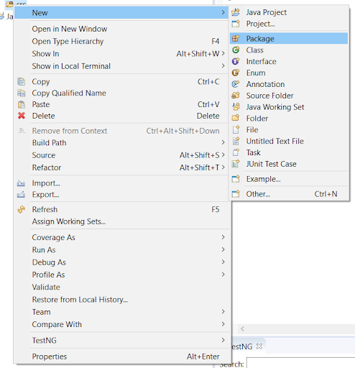

***Creating Package in the Java Project***

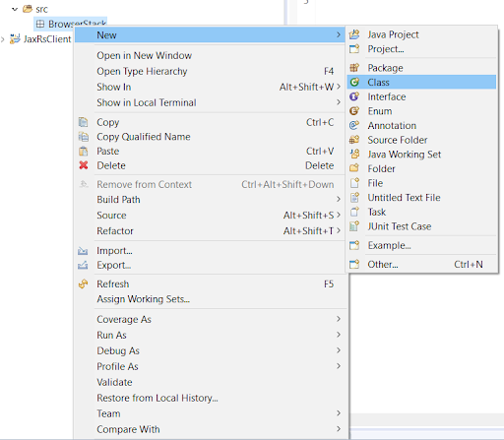  
***Creating Class in the BrowserStack Package***

**Step 5: Add Selenium JARs to the Java Project in Eclipse**

To add the Selenium Jars to the BrowserStack Java right click on the BrowserStack Project folder and select the **Properties** option. In the properties window, click on the **Java Build Path** and **Add External JARs**. Browse and add the downloaded Selenium JARs i.e. Client Combined JAR and all the JARs under the Libs folder, then click **Apply and Close**.

***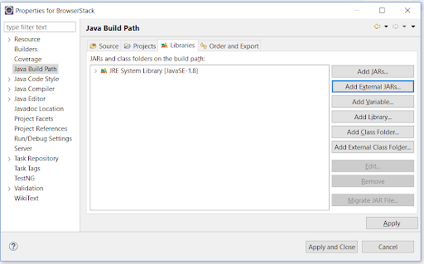  
Adding Selenium JARs in the BrowserStack Project***

This configures Selenium with Eclipse, making it ready to execute the first test script.